Academy of Peace Development

How Healthcare Stakeholders Share Data in Somaliland

And How Crowdsourcing Can Assist in Gathering Data in Constrained-­‐Resource Regions

Mohamed Gulaid Researcher

ABSTRACT

I carried out an assessment study to evaluate health data reporting and sharing in Somaliland between stakeholders to determine major disease outbreaks and widespread child malnutrition. I examined how field data is collected and disseminated between stakeholders by conducting interviews, field trips, analyzing health reports and observation in health posts in Hargeisa. Additionally, I designed a system that uses crowdsourcing application to facilitate information gathering and dissemination to the Somaliland public. In this report I give an overview of healthcare conditions in Somaliland, examine how child malnutrition and emergency disease outbreaks are determined, and finally illustrate how voice-­‐based crowdsourcing application can benefit health information gathering and dissemination in Somaliland.

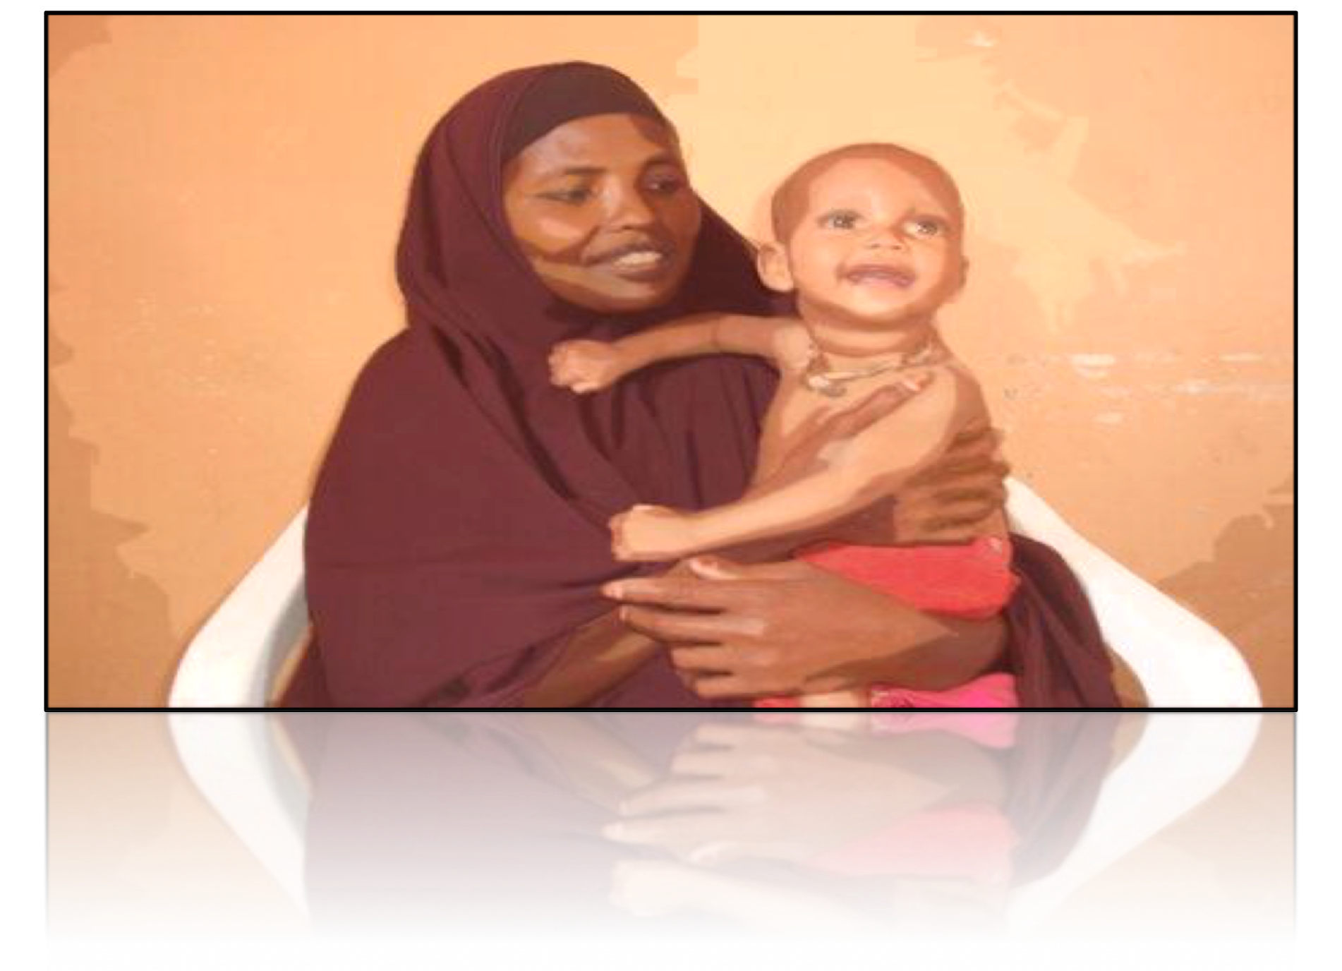

**Source: Oxfam Somalia**

**Contents**

3.0. Overview of Healthcare in Somaliland 6

Ministry of Health Overall Budget (Somaliland National Budget 2012) 9

3.1.1 Methodology to Determine Child Malnutrition within UNICEF 11

* + 1. Reporting Data in UNICEF 11
    2. Methodology of Submitting Data in UNICEF System 12
    3. List of NGO working with UNICEF 13
    4. Data Collection and Dissemination by Ministry of Health 13

3.1.7 Data Analysis within MoH 14

* + 1. Collecting Data about Less-severe Child Malnutrition 14
    2. Food Insecurity and Malnutrition Monitoring 15
    3. Method of Diseases Surveillance by WHO 17
    4. Analysis of Technology and Methods Used to Collect Health Data in Somaliland 18

4.1.2. Crowdsourcing for Low-literacy Population 21

* + 1. The Design of Ila Maqal 22
    2. Practical Scenario of Design 1 25
    3. Design of Ila Maqal II 26

4.1.3 Practical Scenario of Design II 27

4.1.5. Online Interface of Ila Maqal Design: 28

Appendix 30

5.1. References 36

INTRODUCTION

Health indicators in Somaliland are one of the worst in the world according to World Health Organization and UNICEF. Vaccine-­‐preventable diseases like meals and water-­‐born infectious diseases like diarrhea are common and have a high rate of mortality. In addition, because of the civil war and instability in the country for the last 22 years, the health infrastructure of the country are under-­‐resourced and in most cases non-­‐existent. Somaliland Ministry of Health depends on International aid organizations like the UNICEF, WHO, WFP, FAO to sustain operations and technical support.

Of all the civil wars and humanitarian crises in developing countries in recent history, state failure, coupled with a continuous severe humanitarian crisis has nowhere been more devastating than in Somalia. It is difficult to discuss Somalia without giving the context of the geopolitical situation and recap of the ongoing civil war. Somalia has been described as most failed state in the world. After Somalia central government overthrown in 1991, the Somali state effectively ceased to function as an administrative, ideological, juridical and territorial entity (Ali J. Ahmed, 1995). Somaliland (Northwest Somalia), which seceded from the rest of Somalia in May 1991, is continuing its long, slow and expensive process of rehabilitation and reconstruction. Somaliland has many attributes of a state, having a constitution, constitution, multi-­‐party political system, democratically elected local councils, parliament, and president, but Somaliland has not been able to secure international recognition as an independent state (Ali J. Ahmed, 1995). However, there has been creeping informal and pragmatic acceptance of Somaliland as a political reality. The Somaliland government developed low-­‐key bilateral relations with foreign donors like DFID, Danish Refugee Council and neighboring countries like Djibouti and Ethiopia.

Reconstruction of homes, schools, hospitals and health centers had been made possible through community mobilization, Diaspora and donations from international NGOs. Six Regional hospitals and seventy health centers have been rehabilitated and basic primary health care services have been made accessible to most of the population through out the country (Abdilahi, Ministry of Health), but the quality of health care is below standard. Somaliland has some of the worst statistics in the world for maternal and child health. Based on the information from UNICEF, estimates of infant mortality rate was at 132 per 1,000. Less than five years old mortality rate was 224 per 1,000 and maternal mortality stood at 1,600 per 100,000 births.

As part of my of my summer internship, I worked to evaluate current systems used in Somaliland to identify severely malnourished children and surveillance of outbreak diseases. In addition, I designed a crowdsourcing application to allow information gathering and dissemination through mobile phones. Mobile communication technologies are disrupting numerous industries including healthcare. Mobile phones have become inseparable part of life for billions of people. In developing world, mobile technology plays as a conduit for a number of critical services like banking, micro-­‐finance, credit history and health care. Crowdsourcing for information via mobile phones in developing is underutilized area.

In this report, I will provide information what are the current systems used to identify severely malnourished children and how different stakeholders conduct infectious disease surveillance throughout the country. How data is collected and transmitted between stakeholders? How frequently is the data collected and disseminated? Who gets access to this information? After a short analysis, which I will highlight gaps and problems with both systems, I will make recommendations to apply

new technologies to facilitate more accurate data gathering and dissemination. Secondly, I will provide the design and implementation strategies for modern crowdsourcing technologies that will allow health organizations to



**Health Figures in Somaliland (UNICEF, 2012)**



**5% children 0-­‐6 months exclusively breastfed.**

**40.5% households have access to improved water sources. 35.9% children aged 5-­‐14 years engaged in child labor.**

**45.2% of boys, 38% of girls attend primary schools Child mortality: 1 in 9 children dies before their fifth birthday.**



conduct campaign awareness, surveys and feedback gathering.

**1.0. Objective**

Technology and modern communication systems play an increasing role in healthcare. The role of technology becomes even more important in developing countries because of the need to leap over outdated management systems and bureaucracy. Because of the ongoing mobile revolution, developing countries enjoy high mobile communication penetration. The largest telecommunication company in the Somaliland region covers 95% of the country, according to the PR person of Telesom. Relatedly, Somaliland enjoys one of the lowest calling rates in the world. Traditional media mediums like television and radio are less accessible. Somaliland national TV and radio don’t reach beyond the two most populous regions in the country. It is sensible, to adopt mobile technology for data gathering and dissemination.

International Aid organizations and the Ministry of Health under-­‐utilized modern technologies to collect and transmit data. The goal of this report is to evaluate how health data reporting and sharing in Somaliland works and the role technology could play to improve collection and dissemination health data about the emergency disease and chronic malnutrition in children. In addition, I will provide feedback on ways to leverage telecommunication in Somaliland to develop a crowdsourcing platform that allows information gathering and dissemination awareness messages.

**1.2. Scope, Approach and Methodology**

A number of research and investigative questions were developed to investigate and understand how data reporting take place in Somaliland to identify emergency diseases outbreaks and child malnutrition: (i) What is the current system used in Somaliland to help identify severely malnourished children? (ii) Which stakeholders (WHO, Somaliland Ministry of

Health, NGOs) are involved in the system? (iii) Who gets access to this information? (iv) How frequently is the data collected and disseminated?

This is a qualitative report that relies on direct interviews and semi-­‐structured meeting of staff of health institutions in Somaliland, analyzing, monitoring and evaluating reports of health conditions and of International NGOs in Somaliland. I also conduct field trip to the regional office of Moordi Jaax and MCH center in downtown Hargeisa to interact with staff and observe the daily operation of both facilities.

I conducted interviews with the following people in key positions related to my inquiry:

1. **Abdilahi Abdi Yusuf**, *Head of HMIS (Health Management Information System) Somaliland Ministry of Health, (3 interviews).*
2. **Hussein Jama**, *Secretary of HMIS, SL Minister of Health.*
3. **Abdirahman Mohamed**, *Head of Regional MCHs centers in Moordi Jaax providence.*
4. **Dr. Ahmed Jamaa Musa***, Head of the Child Malnutrition Department at the Ministry of Health.*
5. **Rahma Mohamed**, *Nutrition officer UNICEF.*
6. **Awil Haji Ali**, *Health Specialists UNICEF.*
7. **Ali Nassir Anaas**, *Manager of Mother and Child Malnutrition at WFP (World Food Program).*
8. **Nassir Mohamoud,** Director of Operations of WHO (World Health Organization).
9. **Abdi Dahir***, Head of Communicable Diseases Data Collection, WHO.*
10. **Hassan Abdi**, *Manager of Nutrition Program, Somaliland Red Crescent*.

**1.33 Participatory Design Process**

During the design and testing of crowdsourcing system that enables citizens in Somaliland to send feedback and retrieve information, a participatory design session was held for key staff of different health organizations to gather their needs and feedback on proposed designs. I demonstrated an IVR system where people can listen to the instruction / message/survey question and submit feedback. Staff of Ministry of Health gave me feed and they test application. I tuned out the IVR language and navigation menu. Because the system I designed is connected to the Internet, the staff raised legitimate questions regarding privacy, accuracy of data, and potential abuse of the system. These concerns and issues raised valid points and they are addressed in analysis section of the report.

* + 1. **Background Information on Somaliland**

## Geography

Somaliland is about the size of England and Wales with an area of 137,600km² (68,000 sq. Miles) with a coastline of 850 kilometers (528 miles). It shares borders with Republic of Djibouti to the west, Federal Republic of Ethiopia to the south and Somalia to the East. The country is semi-­‐arid and has a warm climate. The average daily temperatures range from 25-­‐35C. Somaliland consists of three main topographic zones: the low-­‐lying coastal plains known as the Guban meaning burnt, coastal range (Ogo), and the plateau (Haud).

## Population

The population of Somaliland is estimated at around 3.5 million. The average population growth rate is 3.1%. Population density is estimated at approximately 25 persons per Sq. Kilometer. 50% of the population are either nomadic or semi-­‐nomadic, while approximately 45% live in urban centers or rural towns. Population concretes in western regions of the country, as environmental conditions are more hospitable. The average life expectancy for men is 50 years while for women it is 55 years.1

## Climate and Rainfall

The general climate is hyper-­‐arid, arid and semiarid. Records collected for over 40 years in Hargeisa indicates that there is the probability of rains during five months of the year but the actual amounts vary considerably. The rainy season has two peaks. The first occurs during April to June and is the more important of the two rainy seasons. This is locally known as the “Gu” and is of significant importance to the nomads and the agricultural communities. This rain is brought up by the southwest monsoon, which blows during this period. Temperatures at this time of the year are somewhat above the yearly average of 21.7C0 with the highest temperature (around 40 o C) occurring in the last half of June. This rainy season is followed by a short period with less rainfall, but with, more significantly, dry strong winds. These winds reach their highest velocities in July.2

# 3.0. Overview of Healthcare in Somaliland

Somaliland has some of the worst statistics in the world of maternal and child health. It is difficult to find accurate data about Somaliland. Large NGOs merge data from Somaliland with Somalia. Because of relative stability in Somaliland, health indicators are less severe. However, Somaliland ranks low on basic health care indicators. UNICEF describes conditions in Somalia overall as “chronic catastrophe‟, characterized by a complex political environment, extreme poverty, food insecurity, conflict and continuous instability.

As defined in Somaliland national development plan, the Ministry of Health is responsible for the health care of the nation. The Ministry operates through a three-­‐tier health provision



1. Somaliland in Figures, *Somaliland Ministry of National Planning 2003*, <http://siteresources.worldbank.org/SOMALIAEXTN/Resources/Somaliland_in_Figures.pdf>
2. Ibid

system. At the lower end are the health posts; then there are the MCH clinics, and the hospitals system. At the lower end are the health posts; then there are the MCH clinics, and the hospitals at the upper end. For a population of 3.5 million, the public health care system is inadequately resourced to meet people’s needs as the following table shows:

**Table 2: Public health facilities**

In the latest reported data, Somaliland’s public health facilities were manned by 86 doctors, 369 nurses, 89 midwives, 4 X-­‐ray technicians and 24 laboratory technologists. For a region with approximate population of 3.5 millions, the accessibility to healthcare is very limited and below standards. Health Posts in rural area are in worse shapes than ones in urban regions. Rural communities are forced to come to the capital of regions to receive better health care.

Alongside the public health care

system, operates a private healthcare system that is still too small but favored by anyone who can afford it. The private sector system consists of General practitioner or specialist doctor surgeries normally attached to a pharmacy, or based in a private clinic or hospital. The following table summarizes the sector’s facilities and personnel as of 2008/9. And in the last few years, Somaliland private sector has witness an influx of foreign specialist doctors, especially from neighboring countries like Ethiopia and Kenya. Although this has led to increase of healthcare quality in the country, it is prohibitively expensive for the average Somaliland citizen.

Table 3: Private sector health provision

Major health distresses that face Somaliland are food shortage, Tuberculosis (TB), child and maternal mortality, measles, and diarrheal diseases, including cholera. Other communicable diseases and HIV are considerable low in Somaliland. But access to quality and consistent healthcare, lack of stable harvest yield, and instability are major barriers.3

Because of lack of resources in Somaliland, the country depends heavily on large international



1. Somaliland National Development Plan 2012, Ministry of Planning.

NGOs on health care operations and enforcement. Somaliland spends roughly 3%, which equates to less than one million USD. Salaries paid to public employees of the health system are Over 75% of the Somaliland budget.4 Working with local partners and MoH, UN agencies concentrate on different aspects of healthcare. For example, WHO works to disease outbreak monitoring, UNICEF on mother and child related health issues, and FAO, WFP work on food security and combating famine.

Table 4: Child and Mother Health Status

**Health Problem 1990 1999 2006 2010**

**2015 (MDG**

**Target)**

**Infant mortality/1000**

152 133 73 53 51



**Maternal mortality/100000**

1100 1044 1013 995 367



The Somaliland health care system operates in a decentralized management system where the delegation of administrative and service delivery functions to the regions and districts. The ministry operates through a three-­‐tier health provision system as follows:

* 1. At the lower end are the health posts, which are small community health clinics.
  2. Regional health offices, which administrate health affairs for the regions.
  3. Main Hargeisa Hospital and National Ministry of Health headquarter.

In the public sector in Somaliland, the functioning health facilities in the country are divided into three main categories such as:

1. Health posts

There are 160 health posts (HPs) in all the regions of the country. These health facilities are available at the village level. According to MoH standards, each health post facility should have at least one traditional birth attendant, one community health worker (MOHL, 2001).



1. Somaliland 2012 National Budget, Ministry of Finances, 2012.
2. Health Centers (Mother and Child Health Center):

There are around 94 health centers throughout the six regions of the country (Ministry of Health 2012). Health centers are mostly located at the district capitals and some main villages. They are staffed with: qualified nurses (usually 1-­‐3), auxiliary nurses (1-­‐2), cleaner, midwife, growth monitoring unit, and basic drug supplies that contain painkillers, antibiotic. Health centers are the most important health facilities providing health services to the children. Most of MCHs have immunization and Growth Monitoring Units.

1. Hospitals:

According to the official documents from the ministry of Health and Labor there are seven functioning Hospitals, which are:

* One National Referral Hospital in Hargeisa
* Five Regional Hospitals
* One District Hospital
* One TB Hospital
* One Mental Hospital

National and regional Hospitals have various Departments such as: Surgical Department, Medical Department, Pediatric (not in all hospitals), Gyn/Obstetric Department, Mental Department in most of the Hospital, TB sections in most of the Hospitals

# Ministry of Health Overall Budget (Somaliland National Budget 2012)

| **Expenses** | **2011 Budget in $** | **2012 Budget in $** | **% Difference** |
| --- | --- | --- | --- |
| Salary Expenses | $1,951,905 | $2,118,569 | + 8.18% |
| Operations costs | $249,700 | $1,626,860 | + 146.77% |
| Drugs, Food, Offices Equipment, Energy costs | $256,222 | $224,526 | -­‐13.18% |
| Maintenance of facilities and Equipment | $51,202 | $35,577 | -­‐36.01% |
| Direct Funding to Public Hospitals, and Building new Facilities. | $44,843 | $129,218 | + 96.94% |
| TOTAL: | $2,509,029.00 $4,005,532 + 45.96% | | |



* + 1. Severe Child Malnutrition

UNICEF defines Acute Malnutrition: as deadly disease that arrives as a consequence of insufficient of inappropriate feeding and a consequence of disease. Without appropriate treatment, acute malnutrition may result in death. Because of lasting drought, lack of security and infrastructures in Somaliland, famine and preventable diseases are common in Somalia.

The main organization that tackles severe child malnourishment in Somaliland is UNICE. UNICEF coordinates with Ministry of Health, local and international NGOs. UNICEF has an established agreement with the Ministry of Health to implement a number of initiatives that monitors, prevent and intervene in cases of child malnourishment. UNICEF in Somaliland has been running integrated programs that help provide prevention, diagnosis and treatment of acute malnourishment cases. Outpatients therapeutic program, in which health post and MCH centers get trained to identify child malnourishment cases and provide therapeutic treatment. UNICEF only targets severe malnourishment cases. UNICEF works with numerous local and International NGOs and the ministry of Health as partners. Each NGO is

responsible of supervising and managing a region in Somaliland. For example, in region of Marodi Jaax, the capital Hargeisa there are about 11 MCH centers managed by HPA (Health Poverty Action).

In addition, UNICEF works in coordination with FAO (Food and Agriculture Organization) to monitor food security and drought in Somaliland. FAO has a dedicated unit that does surveillance and food security analysis in Somalia, Food Security and Nutrition Analysis Unit (FSNAU). Each year FSNAU conducts two comprehensive surveys that monitors food security and drought in Somalia. It provides a broad range of information with timely and relevant information and analysis for better decision-­‐making relating to short-­‐term food insecurity and malnutrition. FSNAU has developed the Food Security and Nutrition Analysis System (FSNAS), which integrates both the conceptual and operational frameworks that the unit utilizes for analyzing food security and nutrition information through a livelihoods-­‐based analysis. UNICEF depends on FSNAU’s technical reports and analysis to make policy decisions.

UNICEF works with the Ministry of Health, local and international NGOs to implement designed program to prevent, identify and raise awareness of malnutrition. Local and international NGOs working in Somaliland get a contract from UNICEF to monitor and implement the UNICEF’s program in specified geographical region or district in coordination with the Ministry of Health. Engaged NGOs are responsible for working with local health centers to:

* + - 1. Train staff of health posts to diagnose new cases.
      2. Train staff to collect and report information about child-­‐mother malnutrition.
      3. Monitors severe cases, which requires a transfer to main hospitals.
      4. Distribute food packages and diagnosis equipment.
      5. Monitor and evaluate the operations of MCHs.
      6. Report to UNICEF headquater in Hargeisa.
    1. **Methodology to Determine Child Malnutrition within UNICEF**

UNICEF is Somaliland employs these methods to diagnosis severe malnutrition among children at MCHs center and health posts.

* Measuring skinfold thickness or the circumference of the upper arm (MUAC measurement). The MUAC measurement requires little equipment and is easy to perform even on the most debilitated individuals.
* Comparing a patient's weight to standardized charts, by calculating body mass index (BMI) according to a formula that divides height into weight.
* Bilateral Oedema: Bilateral oedema (fluid retention on both sides of the body) is a clinical sign indicating severe acute malnutrition. When an individual has

bilateral oedema, body weight increases due to the excess fluid retained.

After the diagnosis of severe malnourished children, MCHs enroll the child in Outpatients Therapeutic Program (OTP), which is designed to treat patients with SAM. Patients with SAM have good appetite and no medical complications. OPT patients get a weekly or biweekly distribution of ready to use daily does of Therapeutic Foods (RUTFs) and routine medicines, medical and nutritional monitoring of patients. Fixed MCH centers or mobile unit can implement OTP procedures. In ideal cases, after patient’s recovery and discharge, he/she would be admitted to less-­‐intensive monitoring program called Targeted Supplementary Feeding Program (SFP).

* + 1. **Reporting Data in UNICEF**

UNICEF and the Ministry of Health of Somaliland have two distinct but similar methodologies to collect data about severe malnutrition among children. UNIC4cf EF has a data reporting system that is specifically designed to collect information about cases in severe malnutrition, whereas the reports of the Ministry of Health collects general health information, wherein children malnutrition is only part of data collection.

Here is a chart illustration of the UNICEF malnutrition reporting mechanism:

Local MCH Center and Health Posts. **[Weekly Rreports]**

Local NGO Partner.

i.e. HPA **[Monthly Reports]**

UNICEF Central OfJice in Hargeisa. **[Monthly Report]**

UNICEF Regional Headquater in Kenya.

**[Quaterly and yearly analsys]**

Malnourished children identified in the MCHs centers. Each MCH center submits a monthly report to the local implementer of UNICEF projects in that specific region. Local partners submit compiled monthly reports of all MCHs centers under their supervision to UNICEF central office

in Hargeisa. In turns UNICEF central office sent the verified and final draft of all regions reports to UNICEF headquarter in Nairobi, Kenya, where data analysis and policy making is made.

UNICEF supplies all contracted MCHs with equipment for growth monitoring, ledgers record data, and guidelines to identify severe malnutrition among children and mothers. Local partners are responsible for the use and maintenance of the equipment and supervising MCHs Staff.

MCHs centers, mobile units, health posts report to designate a local partner with UNICEF using a standardized form from UNICEF. In the form (shown in the appendix) health outpost staff members indicates newly diagnosed cases and categorize by age and gender. The report also indicates discharged cases (cured), death, defaulter (did not return for treatment), and non-­‐ cured. Staffs with local NGOs and with UNICEF are able monitor and get up to date picture of patients at each health center in Hargeisa.

* + 1. **Methodology of Submitting Data in UNICEF System**

Agencies in the lower tier of health care system in Somaliland like MCHs centers, mobile units, and remote health posts submit weekly reports to local partners to indicate new malnutrition cases and discharged ones. Most of the reporting through phone calls. MCHs staff members call local NGOs to dictate needed information. Some health centers submit reports via email or hard copy delivery, but the majority uses phone calls to communicate with local implementers. Because of lack Internet connection and computers, mobile phones are the most convenient way of submitting reports. Because of fleeting and impermanent nature of the phone conversation, local NGOs are compelled to conduct physical monitoring and check up on each MCH on a regular basis to match records.

Subsequently, local partners of UNICEF compile a monthly report that includes bi-­‐weekly reports from all MCHs under their supervision. For example, in the capital Hargeisa, HPA (Health, Poverty Action) is the sole partner of UNICEL on child malnutrition. HPA collects bi-­‐ weekly report from 11 MCHs in Hargeisa and submit one monthly report that encamps all MCHs reports in Excel format via email. UNICEF central office in Hargeisa receives the monthly report from all local and international implementer. In turn, UNICEF office in Hargeisa forwards all reports to UNICEF regional headquarter in Nairobi, Kenya in Excel format via email.

Somaliland is considered part of Somalia, UNICEF policy change and the new implementation is part of a larger process that takes place in Nairobi, New York and Geneva. Most of policymaking and designs take place outside of Somalia mainly because of lack of security and expertise.

UNICEF has clear guidelines to respond to data on the ground. UNICEF shares data with all stakeholders locally and internationally through report publishing and sounding the alarm in case of widespread malnutrition. UNICEF works closely with the Somaliland Ministry of Health to implement new policies or programs. There is an important monthly meeting between MoH, UNICEF and local implementer to assess progress and examine data and analysis reports.

* + 1. **List of NGO working with UNICEF**

Merlin World, HPA (Health Poverty Action), WVI (World Vision International), Finsom, SRCS (Somaliland Red Crescent), Medair, SCODO, USA Mercy, SOS, International medical corps (IMC), Somaliland Red Crescent, THET (Tropical Health and Education Trust).

* + 1. **Data Collection and Dissemination by Ministry of Health**

As I indicated in the previous section, Ministry of Health and UNICEF conduct their own data collection. HMIS (Health Management Information System) conduct general health data gathering that encompass all aspects of public health in Somaliland. HMIS collects all aspects of health information and disseminate to stakeholders and inner departments within the Ministry of Health. However, agencies like WHO or UNICEF rarely use information from HMIS. UNICEF has specific data collection and analysis program done by contracted NGOs through participating health centers. This is redundancy in the system because staffs of health centers fill out similar forms to different stakeholders.

HMIS office is responsible for collecting, analyzing, and dissemination of general health data in Somaliland. HMIS collects data about severe child malnutrition and emergency disease outbreaks. The office is staffed with three dedicated young men. Abdilahi Abdi Yusuf is the director of operations. The office collects weekly, monthly reports and does quarterly analysis and dissemination of data.

The structure of collecting and identifying malnutrition cases and epidemic infectious diseases works by collecting diagnosis cases from following sources: Health Posts, MCHs center (Mother and Child Health Center), hospital, TB centers, and mental health institution. The office does not collect data from private clinics and hospitals except of Manhal Hospital in the capital Hargeisa.

HMIS collects data of the following categories: Outpatient cases, malaria, pneumonia, measles, water related diarrhea, HIV cases, Post Natal Care, birth and complicated deliveries, nutritional surveillance of mothers and children, and data on immunization cases. (Appendix)

Here is an illustration of data reporting chain of the ministry of Heath:

* + - * weekly reports to regional ofJice of health coordination mostly by phone or physical delivery to location

Health Posts, MCHs, Mobile Units

Regional OfJices

* Collects data from all public health facilities in in region.
* compile **monthly** report and send to centeral ofJice in Hargeisa
  + does monthly summary and quaterly analysis.
  + it also dissmeniate information to different stakeholders.

Health Information Management System ofJice in Hargeisa

As illustrated above the Ministry of Health facilities report registry data on a weekly basis to a designated regional office. Most health centers report data via phone calls, where staff at the regional office takes down the information and enter into spreadsheets. Successively, all six regional offices send monthly reports to the central office in Hargeisa that includes a summary of information from each region.

Regional office collects weekly reports from all public health facilities in Somaliland and submits bi-­‐weekly reports to HMIS. HMIS collects health data only from public institution beside Manhal Hospital in Haregeisa, which is a large private hospital in the capitol. MoH is working to create a national standard and policy that will require all clinics, including private ones in the country to submit data to the office Health Information. Most of Health posts call for regional offices to report health data to the regional office. Few health centers, which are located in urban centers, send data via email in spreadsheet format. Other remote health posts deliver physical copy to the regional offices. Successively, regional offices submit bi-­‐weekly reports to the central office in Hargeisa by email using pre-­‐designed spreadsheet template.

In addition, representatives from each regions calls around 8:30 each day to the center of health Information at the Ministry of health in the capital, Hargeisa, to report major incidents and health observations. Two assistants at HMIS transcribe this report. It includes a summary of all observed incidents and health issues of the previous day; this call summarizes a number of infectious diagnoses, injuries from violence, and other indicators. This report is used to identify emergency cases or incidents that result from violence.

The office of health Information uses data reporting standard that is mixed of WHO standard and a system developed at the University of Carolina in Chapel Hill. This standard has helped the office to use internationally approved methods of collecting and disseminating health data between different stakeholders and department of the Ministry.

**3.1.7 Data Analysis within MoH**

The HMIS conducts quarterly analysis that provides raw data analysis and provide context of spread of diseases. MoH sends quarterly report to large mailing list that includes all department of MoH, NGOs and other stakeholder. HMIS uses Microsoft Excel to conduct data analysis and graphical representations of captured data. Each department of MoH depends on this report to make policy changes or implementation. HMIS sends quarterly analysis across the Ministry of Health and hold quarterly meeting to address any concerns.

* + 1. **Collecting Data about Less-­‐severe Child Malnutrition**

Besides UNICEF, the World Food Program (WFP) works to prevent child malnutrition. WFP works mainly to distribute basic and supplementary food to vulnerable populations to combat famine. WFP works closely with the Ministry of Health and local NGOs to assess food security in Somaliland and supply patients with daily supplements of fortified blended food to complement already poor diet. The WFP’s procedure of collecting data about malnutrition is similar to UNICEF’s. WFP in Somaliland concentrates efforts on combating less severe child and

mother's malnutrition cases. WFP works with certified and approved local and international NGOs to coordinate feeding and combating malnutrition at MCHs centers. The WFP’s program is “implemented through functional Maternal & Child Health clinics to ensure that beneficiaries receive both nutrition support, but also all the health interventions necessary for a healthy growth: immunization, de-­‐worming, treatment of diarrhea and other common illnesses, ante-­‐ natal and post-­‐natal medical checkups, etc. Pregnant or nursing women can stay in the program until delivery and/or when the child reaches 6 months of age, while children can remain in the program until they reach 24 months of age.” 5 WFP program is preventative in nature. But patients with suspicious cases of malnutrition can enroll in the program and receive bi-­‐weekly fortified food ration.

WPF’s program aims to treat mild to moderate acute malnutrition in children below 5 years of age, as well as pregnant and nursing women, and to prevent them from sliding further into severe malnutrition. Like UNICEF’s program malnourished children or women are diagnosed based on body measurements (weight, height, Mid-­‐Upper Arm Circumference) using internationally recognized standards. Once in the program, these children and mothers receive a daily supplement of energy and nutrient dense specialized food (e.g. Fortified blended foods or Ready-­‐To-­‐Use Supplementary food) to complement their diet and ensure they regain weight, but also replenish their micronutrient stores. To ensure the food supplement goes to the malnourished child/mother, WFP provides a monthly family ration composed of cereal, pulses, and vegetable oil for the other family members. The duration of treatment usually ranges between 2 and 3 months.

WFP has other programs designed to provide food to vulnerable communities to prevent famine and food crises. WFP works closely with FSNAU (a division within FAO) that is designed to monitor food security in Somalia. FSNAU conducts two large surveys to analysis and examine food security in Somalia. WFP and UNICEF design their projects and policy based FSNAU’s reports.

Similarly, World Food Program works closely with the Minster of Health, local and International NGOs to implement WFP’s programs. NGOs Implementers collect data related to malnutrition from MCHs centers, mobile units, and health posts across the country. These facilities submit weekly reports to partnering NGOs. This data are submitted mainly via phone call to the regional office of coordinator NGO. In rare cases, reports are either delivered or picked up physically to the regional office.

* + 1. **Food Insecurity and Malnutrition Monitoring**

Because of the periodic occurrence of famine and prolonged droughts in Somalia and in the region, The Food Security and Nutrition Analysis Unit (FSNAU) is a special division within FAO (the Food and Agriculture Organization) that is designed to monitor and evaluate security in Somaliland throughout regularly. FSNAU provides information and analysis on food insecurity and malnutrition in Somalia. It provides a broad range of information to local and **international**



1. World Food Program, <http://www.wfp.org/countries/somalia/operations>

NGOs with timely and relevant information and analysis about food insecurity and malnutrition to address underlying causes of famine and malnutrition in Somalia.

FSNAU has developed the Food Security and Nutrition Analysis System (FSNAS) that integrates both the conceptual and operational frameworks that the unit utilizes for analyzing food security and nutrition information. FSNAU has extensive data collection and food monitoring operation that covers most of Somalia. FSNAU has integrated system that not only collects raw data, but it also draws secondary information at all levels. Other UN agencies like UNICEF, WFP and development NOGs use FSNAU reports to draw emergency and development interventions in Somalia. FSNAU has a sophisticated mechanism to communicate crucial information is made available in ways appropriate to different audiences.

This chart summarizes the roles different stakeholders play to fight child malnutrition in Somaliland. Each stakeholder plays a different role, but they overlap greatly in a number of areas.

**UNICEF**

Combat Severe Child Malnutrition.

Distribute Equipment and Basic Nutrition Services Package (BNSP).

Improving infant and young child feeding at community level.

work with MoH to create policies and strategies to combat malnutrition

**Ministry of Health**

Coordination of international donations and the efforts to combat child malnutrition.

Certifying implementer and Jiled NGOs. Collecting public health data.

Respond to emergency and food crises. Manage MCHs centers.

Child

**WFP**

Malnutrition in Somaliland

**FAO**

Distribute foriJied food to MCHs center and vulunrable population.

prevent people from reaching famine conditions.

Provide food in emergency situtations and between harvests.

Build up resilience against food emergencies.

Support of the Somalia's livestock sector and agriculture sector by rehabilitating essential infrastructure.

Crisis mitigation and response to natural disasters.

Collect and analyze data to inform decision-­‐ making and response planning for interventions of FAO, and other UN agencies. (FSNAU division)

* + 1. Communicable Diseases Surveillance

WHO (World Health Organization) has comprehensive and well-­‐resourced apparatus to do diseases surveillance in Somaliland than the Ministry of Health. It monitors the following categories of diseases:

* + - * Communicable Diseases (bacterial and protozoal diarrhea, hepatitis A and E, typhoid fever, schistosomiasis, and rabies)
      * HIV.
      * Tuberculosis (TB).
      * Malaria, measles.
      * Polio.

In addition, WHO carries out vaccination against polio and other infectious diseases. Vaccination campaigns require ongoing monitoring of polio cases, especially in remote areas. This allows WHO to collect data about other diseases across the country on a regular basis like TB, malaria, measles, and diarrhea related diseases in all regions in Somaliland. It has regional officers and mobile units who communicate with large percentages of MCHs, hospital and remote health posts. WHO does not use data collected from Ministry of Health. This creates redundancy and a breakdown in communication between critical stakeholders. Main reason WHO does not depend on MoH’s data is the lack of confidence on methods employed by the minister of health and lack of communication between the two agencies. WHO in Somalia does not grant funds to external NGOs.

* + 1. **Method of Diseases Surveillance by WHO**

WHO collects data from 54 health facilities in Somaliland out of 254 public facilities in Somaliland. These facilities participate in WHO’s campaigns like child vaccination and diagnosis of major diseases like TB, AIDS. These facilities consist of mobile units, regular MoH’s health posts, hospitals, and MCHs centers. These facilities are strategically distributed across Somaliland to reflect diversity of health conditions in Somaliland. There are six regional offices that collect data from these facilities and three additional mobile for all six regions in Somaliland that receive data and also work in coordination with health posts to verify information before submission to the central office in the capital Hargeisa.

All 54 health care centers submit daily report to a regional office of polio surveillance mostly via phone call. The regional office collects information from office and submits weekly report to a central office in Hargeisa via email. In turn WHO office in Hargeisa submits weekly report to the regional office in Nairobi. The Communicable Disease Surveillance and Response (CSR) team collects data about the following cases: 1) Cholera, 2) Shigellosis, 3) Measles Acute Flaccid Paralysis, 4) Hemorrhage, 5) Diphtheria 6) Whooping cough, 7) Malaria, 8) Neonatal Tetanus.

The report categorizes diagnosis cases by gender and age. The collected data are succinct but it is designed to monitor outbreak of known diseases in the region. (Appendix).

WHO publishes data after a quick verification online with a short summary of weekly observation. This allows concerned NGOs to follow data in real-­‐time. WHO has established a consortium of health organizations that are conducting operations in Somalia. Somalia Health Cluster (SHC) has update and vibrant site that publishes latest data at the field level. SHC is made up of more than 40 international and national humanitarian health organizations that

have been working together over the past four years to build partnerships and mutual understanding and to develop common approaches to humanitarian health action in Somalia.6

Here is chart that shows the flow of data from health posts to the regional office in Hargeisa.

* weekly reports to regional ofJice of health coordination mostly by

Regional Polio Monitoring and

Eradication Center • Complie all data from the

country. format data in

standarized WHO format

WHO Regional Headquarter in Kenya.

* Conduct Analysis and

phone or physical delivery

to location

Health Posts, MCHs, Mobile Units working with WHO

* compile **Weekly** report per region and sends via email to centeral ofJice in Hargeisa.

ande send to WHO regional

headquarter in Nairobi, Kenya.

WHO Central OfJice in Hargeisa

provide feedback to Somaliland ofJices.

* Formulate and design policies based on received data.

In comparison, the Somaliland Ministry of Health conducts its version of Communicable Diseases Surveillance (CDS). This collection of data is part of a biweekly gathering of general information about health data that includes all health indicators. I show how the Somaliland Ministry of Health collects and transmit data.

* + 1. **Analysis of Technology and Methods Used to Collect Health Data in Somaliland**

All stakeholders use outdated methods and transmit data in an inefficient manner. Health posts at the bottom of the chain of command make phone calls to report data and the regional office fills out data for each organization on hard copy (printed Excel form). This system is prone to mistakes and unsynchronized recordkeeping. Project and E&M (Evaluation and monitoring) managers conduct monthly evaluation process to examine the records of selected health posts to match the registered and submitted data. This is an unnecessary add-­‐on of the operation of already financially strained organizations. Smart or Java enabled phone could replace to submit data and synchronize within regions. Collecting clinical and outpatient data using smart phone is already in use in places like Kenya.

Quality of public health measures depends on data reported by health care providers, and information technology makes such reporting easier than ever. However, data are often structured in different terminologies and formats, making data interface complex and costly (Shapiro, et al, 2011). Integration of public health data from different sources is a problem exclusive in Somalia. More matures system like the United States health system struggles to



1. Somalia Health Cluster, <http://healthsomalia.org/>

synchronize and use available public health. The Ministry of Health should establish standards for health exchange between stakeholders. As the technology rapidly changes and different format are being introduced or upgraded, regulators should guide this integration process by announcing guidelines, requirements and giving incentives to early adopters.

Mobile technologies should replace reporting instruments from MCHs centers and health posts to the regional office. Currently the clinic uses phone calls to report weekly and daily reports.

Tools like

Front line SMS, Rapid SMS, Google’s Open Data Kit, and EpiSurveyor are amazing tools that collect interactive SMS, form like SMS, pictures and Geo-­‐tag location of the input data.

I recommend Google’s open data kit. Open Data Kit (ODK) is a free and open-­‐source set of tools which help organizations author, field, and manage mobile data collection solutions.7 The only limitation of ODK is that it works on Android devices. ODK provides an out-­‐of-­‐the-­‐box solution for users to:

* Build a data collection form or survey (XLSForm is recommended for larger forms);
* Collect the data on a mobile device and send it to a server; and
* Aggregate the collected data on a server and extract it in useful formats.
* health surveys with GPS locations and images,
* Multimedia-­‐rich nature mapping tools.
* Filtering capability of SMS.
* Synch sms into email account.

4.1.0 Examination of Telecommunication Structure in Somaliland

Telecommunication in Somaliland is one of the most sophisticated networks in the region. People can have access to voice, data, mobile banking, landline, and affordable international calls. Because of lack of regulation and limited taxing system, telecommunication thrives in Somaliland. Mobile communication is relatively cheap compared to neighboring countries.

There are six mobile telecom operators in the country, namely, Telesom, Telecom, Somtel, Nationlink, Africa Online and Solteco. However, two main companies dominate telecommunication in Somaliland, Telesom, Somtel. Local calling rate on Telesom’s network is

$0.04/minute where the second largest mobile telecommunication company (Somtel) charges

$0.004/minute. International calling rates are affordable. Mobile network coverage in Somaliland is remarkable. Telesom covers approximately all towns, small villages and main road across Somaliland. The largest telecommunication company in the Somaliland region covers 95% of the country. Telesom has an estimate of 600,000 subscribers.



1. Google Open Data Kit, <http://opendatakit.org/>

In addition to voice and SMS popularity in Somaliland, mobile banking has been a huge success. Telesom offers ZAAD service. ZAAD allows subscribers to transfer money via text messages to other mobile phone subscribers within the network. ZAAD is also connected to Salaama Bank, where people can link their mobile phone to a checking or saving account.

In comparison to mobile penetration, Internet is lacking in Somaliland. Telecommunication uses expensive satellite to connect to the Internet instead of fiber optic cable. This makes the costs of subscribing to the Internet services costly for the majority of the population in Somaliland.

However, East Africa fiber optic cable is expected to arrive in Somaliland to provide high speed Internet next year. With arrival of high speed Internet, prices are expected to go even lower and introduce new services. Despite the remarkable advances made in the telecommunication sector, inter-­‐connectivity between the telecom operators has been elusive in Somaliland.

Subscribers with different carriers cannot communicate with each other. The biggest operator so far rejected to join networks. This has caused fragmented market and monopolization of market by the largest telecom operator.

* + 1. Crowdsourcing

Crowdsourcing is a complex system that involves outsourcing tasks to a distributed group of people. The difference between crowdsourcing and ordinary outsourcing is that a task or problem is outsourced to an undefined public rather than a specific body, such as paid employees.8

Modern digital communication technologies have allowed us to stay connected, retrieve and send instantly. This has enabled many industries to engage millions of people in product promotion or information gathering. Crowdsourcing has become a powerful mechanism for accomplishing work online and creating interactive feedback systems. Hundreds of thousands of volunteers have completed complicated, knowledge-­‐based tasks including creating the world most comprehensive encyclopedia (Wikipedia.org), classifying craters on planetary surfaces (clickworkers.arc.nasa.gov), deciphering scanned text (recaptcha.net), and discovering new galaxies (galaxyzoo.org). Crowdsourcing also proofed to be a successful commercial strategy for accomplishing micro-­‐work (www.mturk.com). Recent public health empirical studies have utilized social media sites to mine data about epidemics using real-­‐time monitoring of social media communication. For example, in Kenya, researchers have mapped precisely how human travel affects the spread of malaria in Kenya by using cellphone location data. According Caroline Buckee, an epidemiologist at the Harvard School of Public Health, this effort is the largest ever to use cell phones data as an epidemiological tool.

Use of mobile phones is pervasive in developing world. It has become a tool to communicate, bank, and receive critical information about health and market news. However, the use of mobile phone for health related purposes in almost non-­‐existent in Somaliland. In places like



1. Jeff Howe (2006). "The Rise of Crowdsourcing", Wired Magazine.

Kenya and Tanzania, patients can receive health reminders, critical information about common diseases like TB or malaria. Relatedly, Ushahidi has put Africa’s crowdsourcing on the map, as its platform was effectively used to monitor the violence of 2002 Kenya elections. In Zambia, human rights and civic organizations leveraged crowdsourcing to gather information to map the Typhoid cases in Zimbabwe, providing critical data to assist with managing the epidemic. 9

However, crowdsourcing in healthcare context is slightly problematical than in other settings, because it involves relying on strangers to do tasks used to be done by hired personals. False data in healthcare can result in grave outcomes. Also, it is difficult to verify if the submitted information or data are submitted by an informed person. Mining social media sites and search engines for trends and keywords can reveal what are people are concerned about, but too often this can be a reaction to up-­‐going trends with emergency attributes. Nevertheless, crowdsourcing can prove extremely useful for gathering feedback from communities and disseminating information in a speedy manner.

In this section of this report, I have been working to design and test crowdsourcing tool that heavily geared towards illiterate people in developing countries. This technology utilizes voice to gathering and disseminating instead of text messages. Majority of the population in countries like Somalia uses mobile for voice mainly. In Somaliland for example, people use predominantly to make phone calls, listen to radio, and listen to music, religious sermons.

Additionally, low literacy led me to use voice to gather voice-­‐messages instead of text messages.

* + 1. **Crowdsourcing for Low-­‐literacy Population**

Today’s mobile phones, especially smart phones are designed to meet the needs for people in the developed world. Subscribers in developing countries, however, now represent the majority of 2.4 billion mobile phone users worldwide.10 Africa and India are currently the fastest growing mobile phone market in the world. Over the past five years the continent's mobile phone use has increased at an annual rate of 65 percent -­‐ twice the global average. For example, In June of 1999, Kenya had 15,000 mobile phone subscribers. By the end of 2004 the country had 3.4 million subscribers, and in the last 18 months this number has grown to over 5.6 million, despite the fact that only 200,000 Kenyan households have electricity.11

I have been working to design a crowdsourcing application that would help illiterate people to submit and retrieve information using voice interaction interface. There are exiting technology that allows people to submit information via SMS. Ushahidi, Google’s Open Data Kit and Frontline SMS allow public to submit information in real-­‐time. These technologies allow Geo-­‐ tagging, integration with popular social media site and cool visualization. But the SMS present barrier, where literacy level is low. The literacy rate in Somalia estimates around 37.8% of the adult population (UNESCO, 2000-­‐2007). There is no independent figure of literacy levels in



1. <http://crowdfundamerica.org/crowdfund-international/africa/>
2. MIT’s EPROM Center 2009, <http://media.mit.edu/ventures/EPROM/whyafrica.html>
3. IBID

Somaliland. The majority of the Somaliland population uses the phone primarily to make phone calls. Therefore, I had to take in consideration designing an application that majority of the population could use easily.

The purpose of this application is to allow the Somaliland public to participate in information gathering and reporting. Because of lack of transportation infrastructure and financial resources, Somaliland’s Ministry of Health depends on WHO, UNICEF, FAO, WFP to gather critical data about food security and outbreak of major diseases. Somaliland has a thriving telecommunication infrastructure and high mobile penetration throughout the country.

Reaching out to Somaliland public via mobile phones is an obvious solution. This application could be used to allow the Somaliland public to report disease outbreaks, food shortage, and senses gathering in emergency situations. Additionally, it could be used to conduct surveys and to disseminate critical information.

* + 1. **The Design of Ila Maqal**

I named the application Ila Maqa, which translates “Listen with Me” in Somali. Ila Maqal works with Voxeo’s Prophecy IVR (Interactive Voice Interface) Platform, Ila Maqal XML application, Drop Box APIs and YouTube APIs. Integration of Drop Box, YouTube APIs with Voxeo is developed by the Microsoft Research group in India that is specialized in software development for emerging markets. This package will be released as an open source IVR platform next year. I have been an early collaborator to develop a telephony forum for citizens in Somaliland who have no access to the Internet to receive information and submit feedback on peace related issues. I designed the XML application on top of Microsoft’s soon-­‐to-­‐be-­‐release platform.

In my application, we are crowdsourcing data sensing and general health reports using an interactive IVR system that is utilizes cloud computing. IVR -­‐ short for Interactive Voice Response -­‐ is a technology that automates interactions with telephone callers. IVR solutions enable users to retrieve information, including bank balances, flight schedules, product details, order status, movie show times, and more from any telephone. Additionally, IVR solutions are increasingly used to place outbound calls to deliver or gather information for appointments, past due bills, and other time critical events and activities.12

IVR systems have not been utilized widely in emerging markets to enhance economic development and cost reduction. SMS has wider adoption because of easy use and cost. Additionally, limited voice recognition and machine learning for local languages prohibit applications of IVR system in mobile phone development in emerging markets.

The application is designed to allow callers to make standard phone calls to retrieve information on pre-­‐recorded IVR system and also submits feedback. Callers can receive instructions on how and what to report. This system can be used to gather, disseminate information, conduct surveys, and crowdsource health information gathering for the public.



12 <http://www.voxeo.com/library/ivr.jsp>

The system consists of three technical components:

1. An IVR part that allows callers to interact with pre-­‐record messages and also submit feedback, answer and short health report.
2. A cloud-­‐based backend that synchronizes calls from different regions (if needed), and upload recordings of callers to drop box, Youtube and facebook, and wordpress based websites.
3. A visualization part that maps calls on Google maps or Ushahidi.

The system is designed to connect callers in rural areas who use mobile phones primarily to make voice calls to the Internet and popular social media sites like YouTube, Facebook and Wordpress blogs. International observers and concerned citizens can follow feedback from people in Somaliland on Facebook page, YouTube channel or Wordpress blog.

When there is a new announcement, a bloc SMS is sent through the local mobile phone company or Frontline SMS. Once callers receive SMS, they can dial a toll free number to retrieve and submit information. The voice interface of Ila Maqal is interactive and flexible. It could be automated or pre-­‐recorded. Callers can call a local phone number and hear the content of the service by navigating simply designed menu. At the end of each health announcement, callers can respond or post feedback to each announcement. Public responses can be made public or hidden. Additionally, the backend of Ila Maqal, upload the content of telephony application online on Youtube, Facebook, Drop Box or regular website. This option is designed synchronize callers from different geographical location and area codes into one online and telephony forum. Callers can avoid making long-­‐distance calls to hear what other people in different are discussing. This backend is also designed to connect rural communities to the internet. A whole thread of conversation (a health announcement and the public feedback to that announcement) becomes a YouTube playlist that can be embedded anywhere on the web. This is important because main message and public’s reaction can be listed as a YouTube playlist that connected by tags and other Youtube’s API features that allow connections.

Ila maqal mimics how readers comment on the blog or Facebook posts online. Messages have a main message “official announcement” and list of comments and responses from callers. Users can listen to what other callers are calling about. This specifically is designed to encourage callers to hear concerns from other callers and choose to respond to them.

Additionally, local moderator has the ability to filter messages and choose not to post them online and on the telephony forum. Relatedly, calls can be saved as audio files and shared on the Drop Box between NGOs. Calls can be filtered by length, area code and time of the call.

I am using Frontline SMS to notify listeners whenever there is a new message. Here are illustrations how ila Maqal works:

* + 1. Alterative Designs

I came up with two different designs for Ila Maqal:

1. Version 1 that allows people to access other people’s feedback and comments.
2. Version 2 that blocks access to other people’s feedback. Because of privacy reasons and concerned about the accuracy of submitted feedback, I disable making accessing public feedback.

Version 1 incentives other people use the service by allowing them to access other people feedback. It lets the public listen to other people are discussing. The second version disables access to other people’s feedback. This was suggested by Abdilahi Yusuf. Abdilahi was concerned that people won’t submit information about their health if that information is public. However, people are less inclined to send private information about their private lives if they don’t see other people doing the same thing. Other option that could be added is to give callers an option at the end of their recording to make their announcement public or not.

This flow chart illustrates the IVR structure of Design, one of Ila Maqal:

This flow chart illustrate IVR structure of Design one of Ila Maqal:

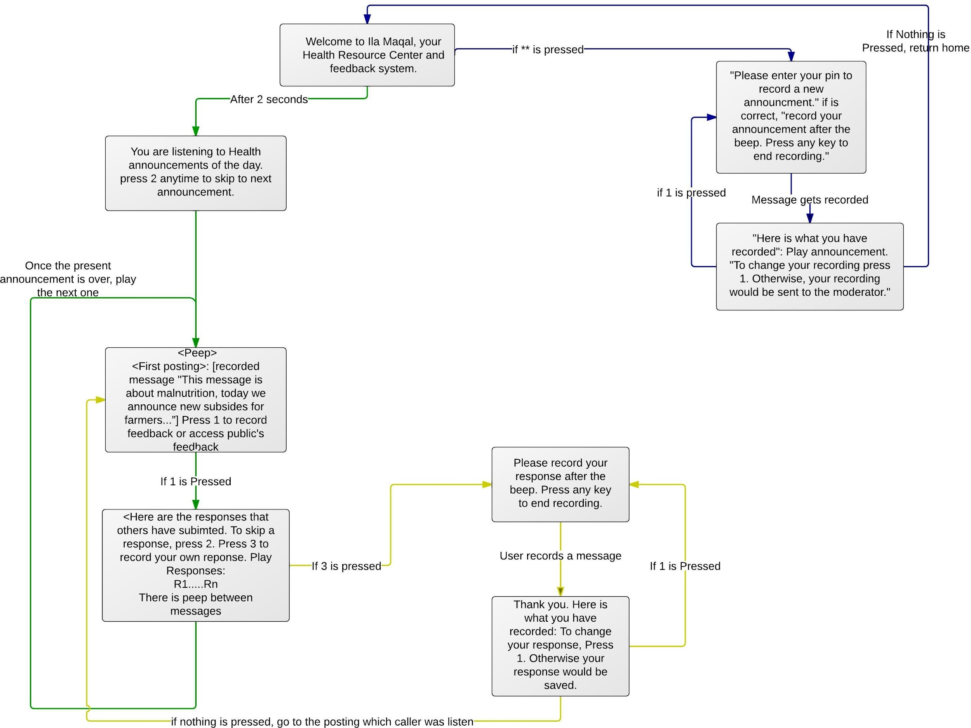

| Facilities/staff | Number |
| --- | --- |
| Hospitals | 7 |
| Mental clinics | 3 |
| Pharmacies | 779 |
| Beds | 228 |
| Doctors | 25 |
| Nurses | 45 |
| Midwives | 24 |
| X-­‐ray technicians | 2 |
| Laboratory technicians | 20 |
| Pharmacists | 9 |

* + 1. **Practical Scenario of Design 1**

Ministry of Health in Somaliland is attempting to assess the spread of malaria in Eastern regions of the country. A public health official from the MoH posts a prerecorded message or records a message by calling the application using any phone. The message gets posted on the ila maqal telephony forum after a trained public health outreach specialist verifies the content of the message. Here is the process of recording the new message.

1. A MoH official calls Ila mqal toll free number. He/she is presented with easy to navigate IVR menu (Interactive Voice Response) to record an “official announcement”. The menu to record “official messages” is hidden. Only authorized people are told how to record an official message. Only by pressing ** (double asterisk) the hidden menu is revealed. “Official recorder” is promoted to record a new message. For example, the message states the following: “There are growing concerns that there is wide-­‐spread malaria in Sool and Snag regions because of the ongoing rainy season. In this following message you will hear instructions on how to identify

malaria symptoms. Please use this hotline service to report new cases in your area.”

1. The message gets recorded into a local server, and a public health outreach specialist gets notification that a new message has been received via email.
2. The moderator approves the message. The message gets uploaded automatically in the Ila Maqal forum, YouTube, Facebook page, and into dedicated site for the service.
3. Following callers can listen to the “official announcement” and choose to respond to it or post questions or comments.
   1. A caller from Arigabo in Snaag posts: “My name is Abdi, I own drug store in Arbigabo, I want to report there are increasing numbers of people with symptoms of malaria in the town. I want to ask for MoH to take preventative measures in Arigabo. It rained hard for the last few weeks."
4. Responses get listed after the “official message.” This creates a thread of messages on the system of official announcement followed by the public responses to this official announcement.

**Messages are listed as following:**

1. **Message one**: “Official announcement.”

At the end of the first message: [Prompt] <**please press 1 to respond or hear responses from other callers to this message. Press 2 to go to the next news item**>

*Pressed 1 (Sub-­‐menu):*

Option one: [prompt] <Now you can hear responses from other callers; you can **also press 3** to record a comment>

1. *Messages Two*: “….”, and callers are presented with same sub menu.
   * 1. **Design of Ila Maqal II**

This flowchart illustrate IVR interface of the second design.

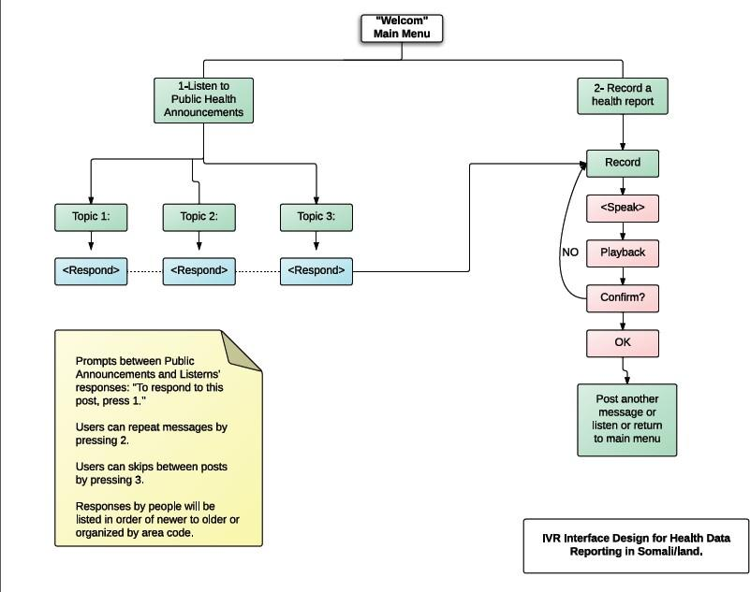

**4.1.3 Practical Scenario of Design II**

**Main Menu:** “Welcome to Ila Maqal, you telephony center health information.”

**Press 1** to get current news and information about health in your region. **Press 2** to record new health report or to submit any concern, question. There are three news/information in this section, please make your selection:

**Press 1** to hear information about child malnutrition or to submit concern about child malnutrition

**Press 2** to hear or submit information about Malaria

**Press 3** to hear or submit information about diarrhea

**Recorded Message 1**: about child malnutrition: “Because of ongoing drought season in the country, there is growing concern about malnutrition among vulnerable population, especially

children. Here are some symptoms of suspected malnutrition of babies and children: lose of weight, children who are malnourished may be skinny or bloated and may be short for their age (stunted), pale skin, thick, dry, and easily bruised skin. Rashes and changes in pigmentation are common. If you suspect your child has any or combination of these, please bring your child to the nearest MCH center, or leave message on our system.”

**Press 1** to leave respond to this message, press 2 to repeat it, 3 to go to next message:

*Pressed 3* or nothing 🡪🡪 **Recorded Message**: “…” [Same cycle of instructions]

*Pressed 1:* please record your message after you peep, press any number when you finish recording,

<User records a message>

**Please here is what you recorded, press 1 to change it, otherwise your message would be saved.**

* + 1. **Online Interface of Ila Maqal Design:**

Here some Screen captures that show how ila-­‐maqal works online. All the telephone conversations on ila maqal interactive IVR system are turned into Youtube videos which can be posted as playlist on Facebook or any other website. This features allows the outside world to listen to discussion taking place in Somaliland. In addition, communities outside of Somaliland can respond to youtube post and that responds becomes part of the conversation.

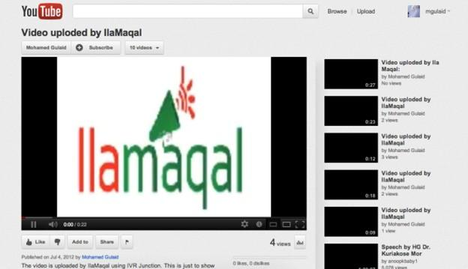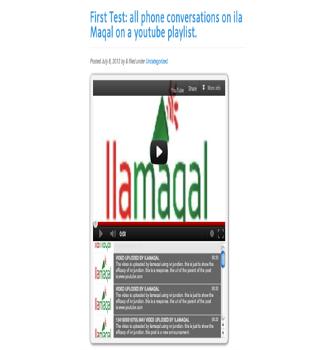

This interface allows embedding a youtube playlist into other sites. The main announcement is listed on top of this widget, where public’s reaction is listed as playlist that can be navigated easily.

Phone calls of health announcements and public reaction to these messages on youtube.



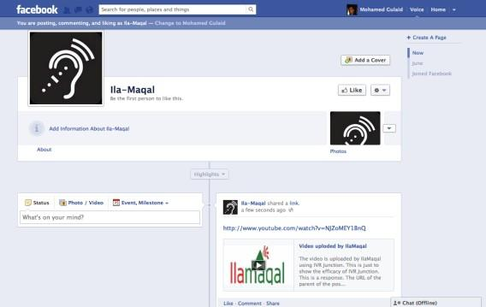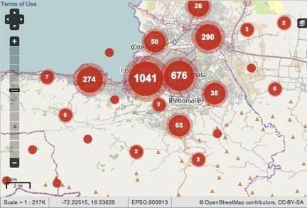

Youtube Videos can be posted online immediately or later to share with the international community realities on the ground.

Also videos can by embedded and visualized on Google maps

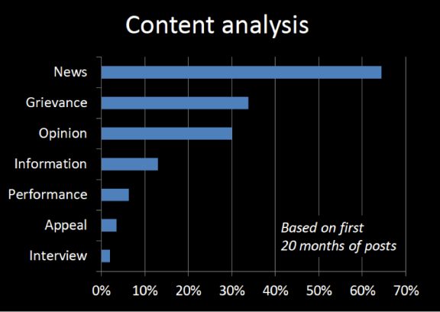 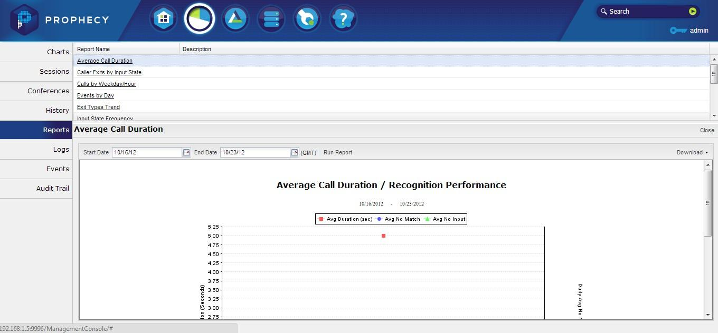

Basic analytics techniques allows smart monitoring of natures of calls

Prophecy platform allows collecting smart analytics about the service like, duration, time of call, most popular features, trends, etc.

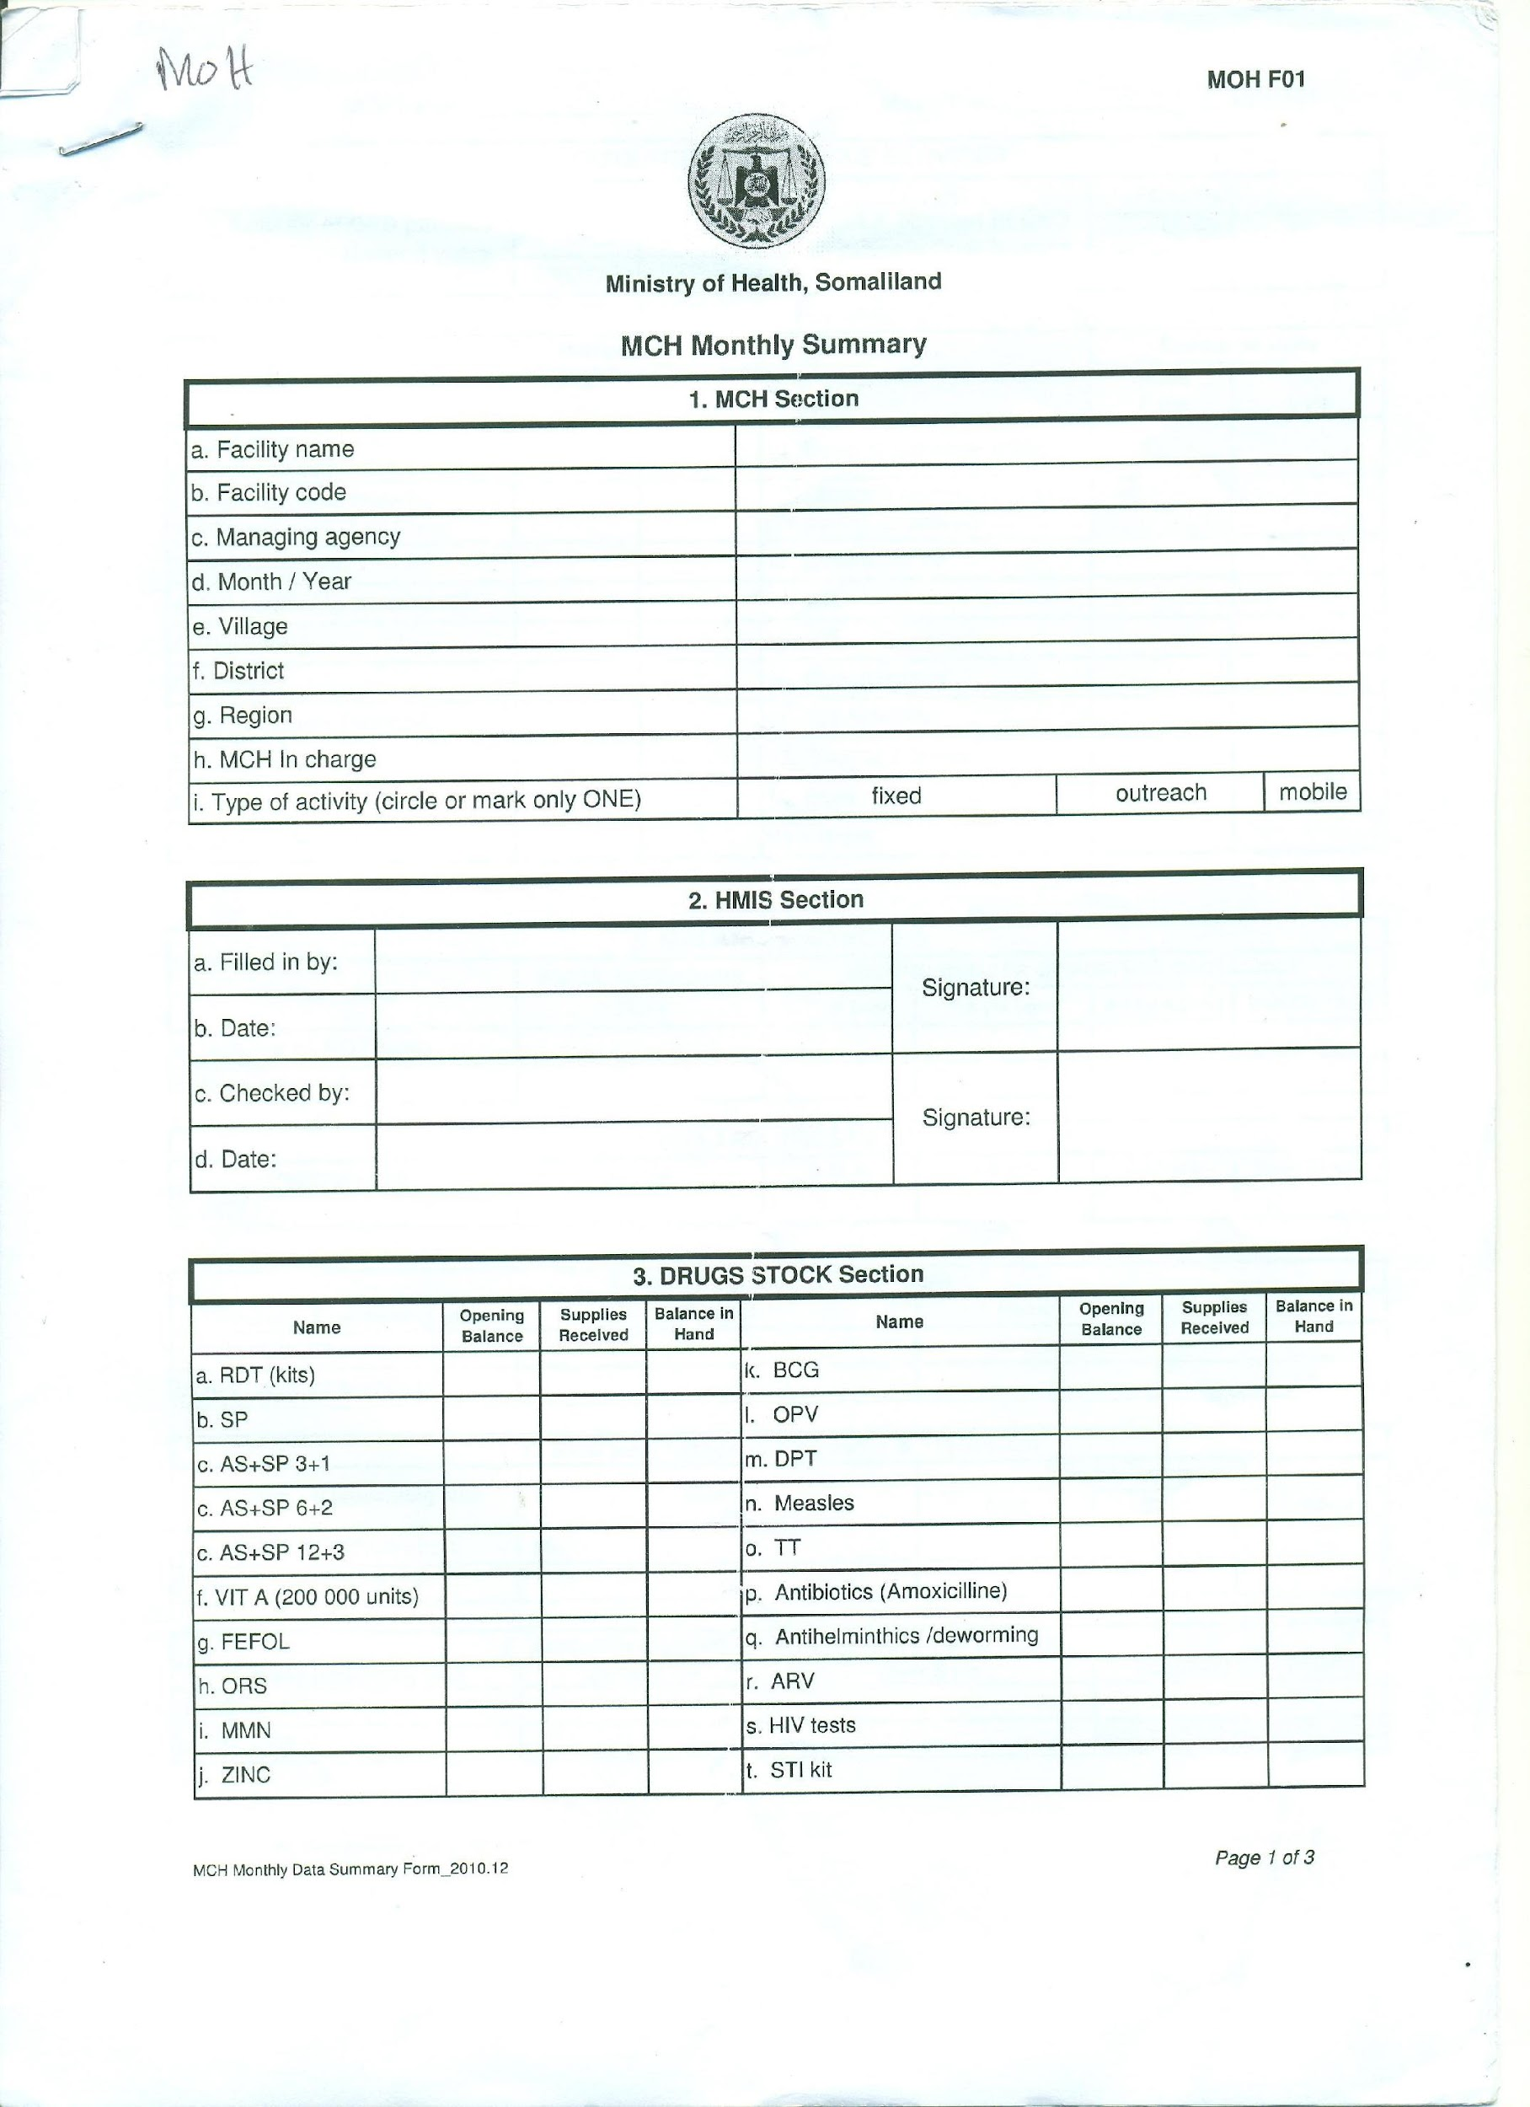

# Appendix

**Figure 1: Monthly Report used by six regional health offices to report HMIS (Health Management Information system. This form (3 sheets) covers all aspects of healthcare issues and conditions.**

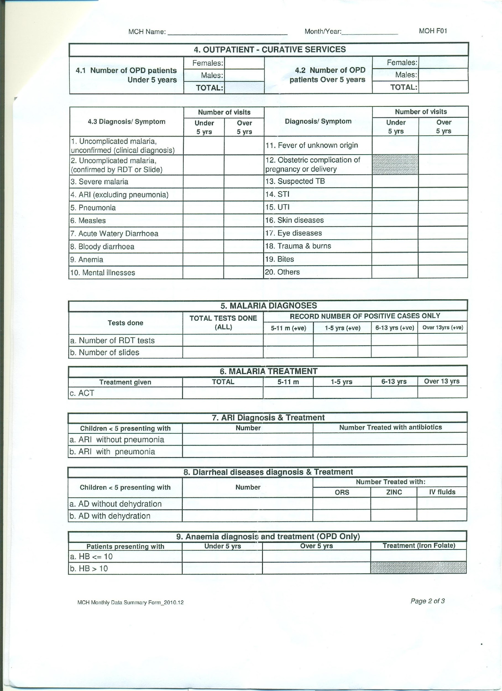

**Figure 2: Figure 1: Monthly Report used by six regional health offices to report HMIS (Health Management Information system. This form (3 sheets) covers all aspects of healthcare issues and conditions.**

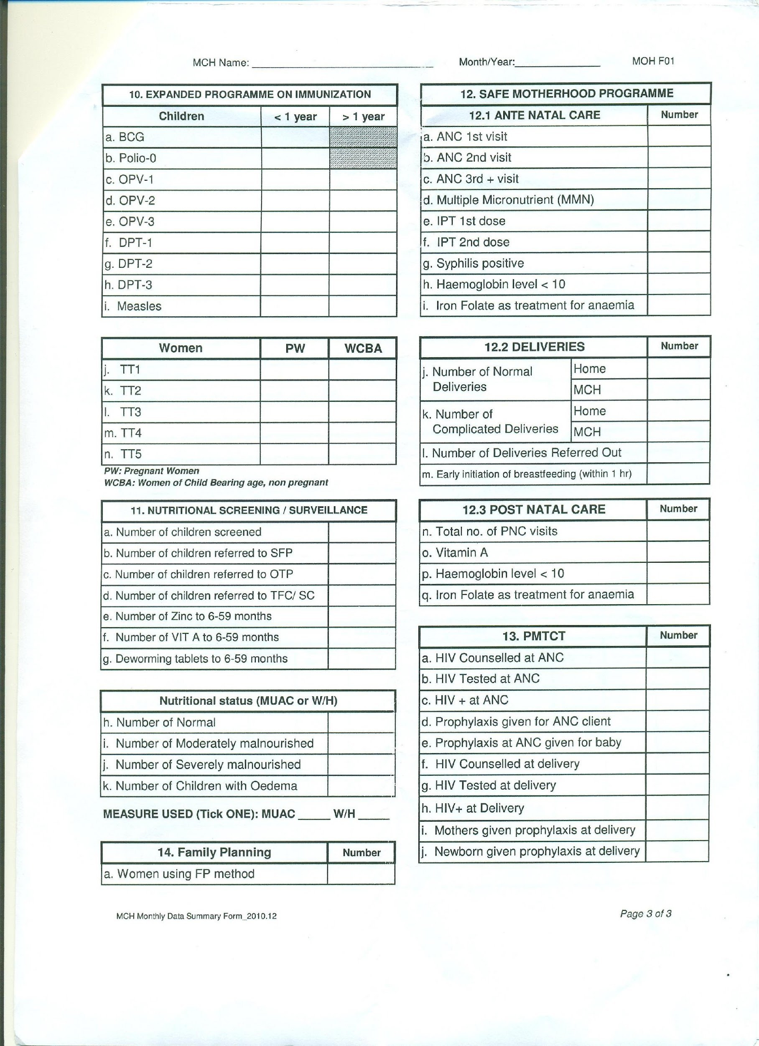

**Figure 3: Figure 1: Monthly Report used by six regional health offices to report HMIS (Health Management Information system. This form (3 sheets) covers all aspects of healthcare issues and conditions. Sheet 3.**

**Figure 4: UNICEF monthly report from implementers to UNICEF headquarter in Haregeisa. This report summarizes diagnosis into Outpatient Therapeutic Program (outpatient Care) and Stabilization Center (Inpatient Care) SC.**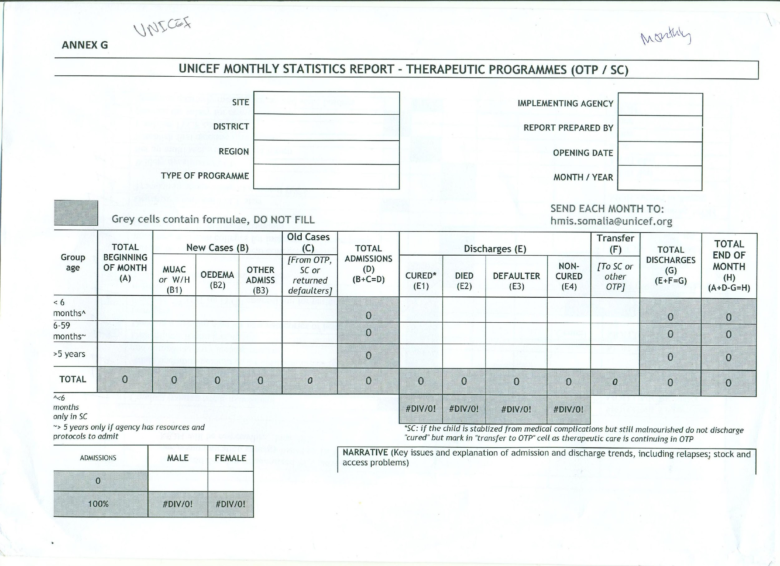

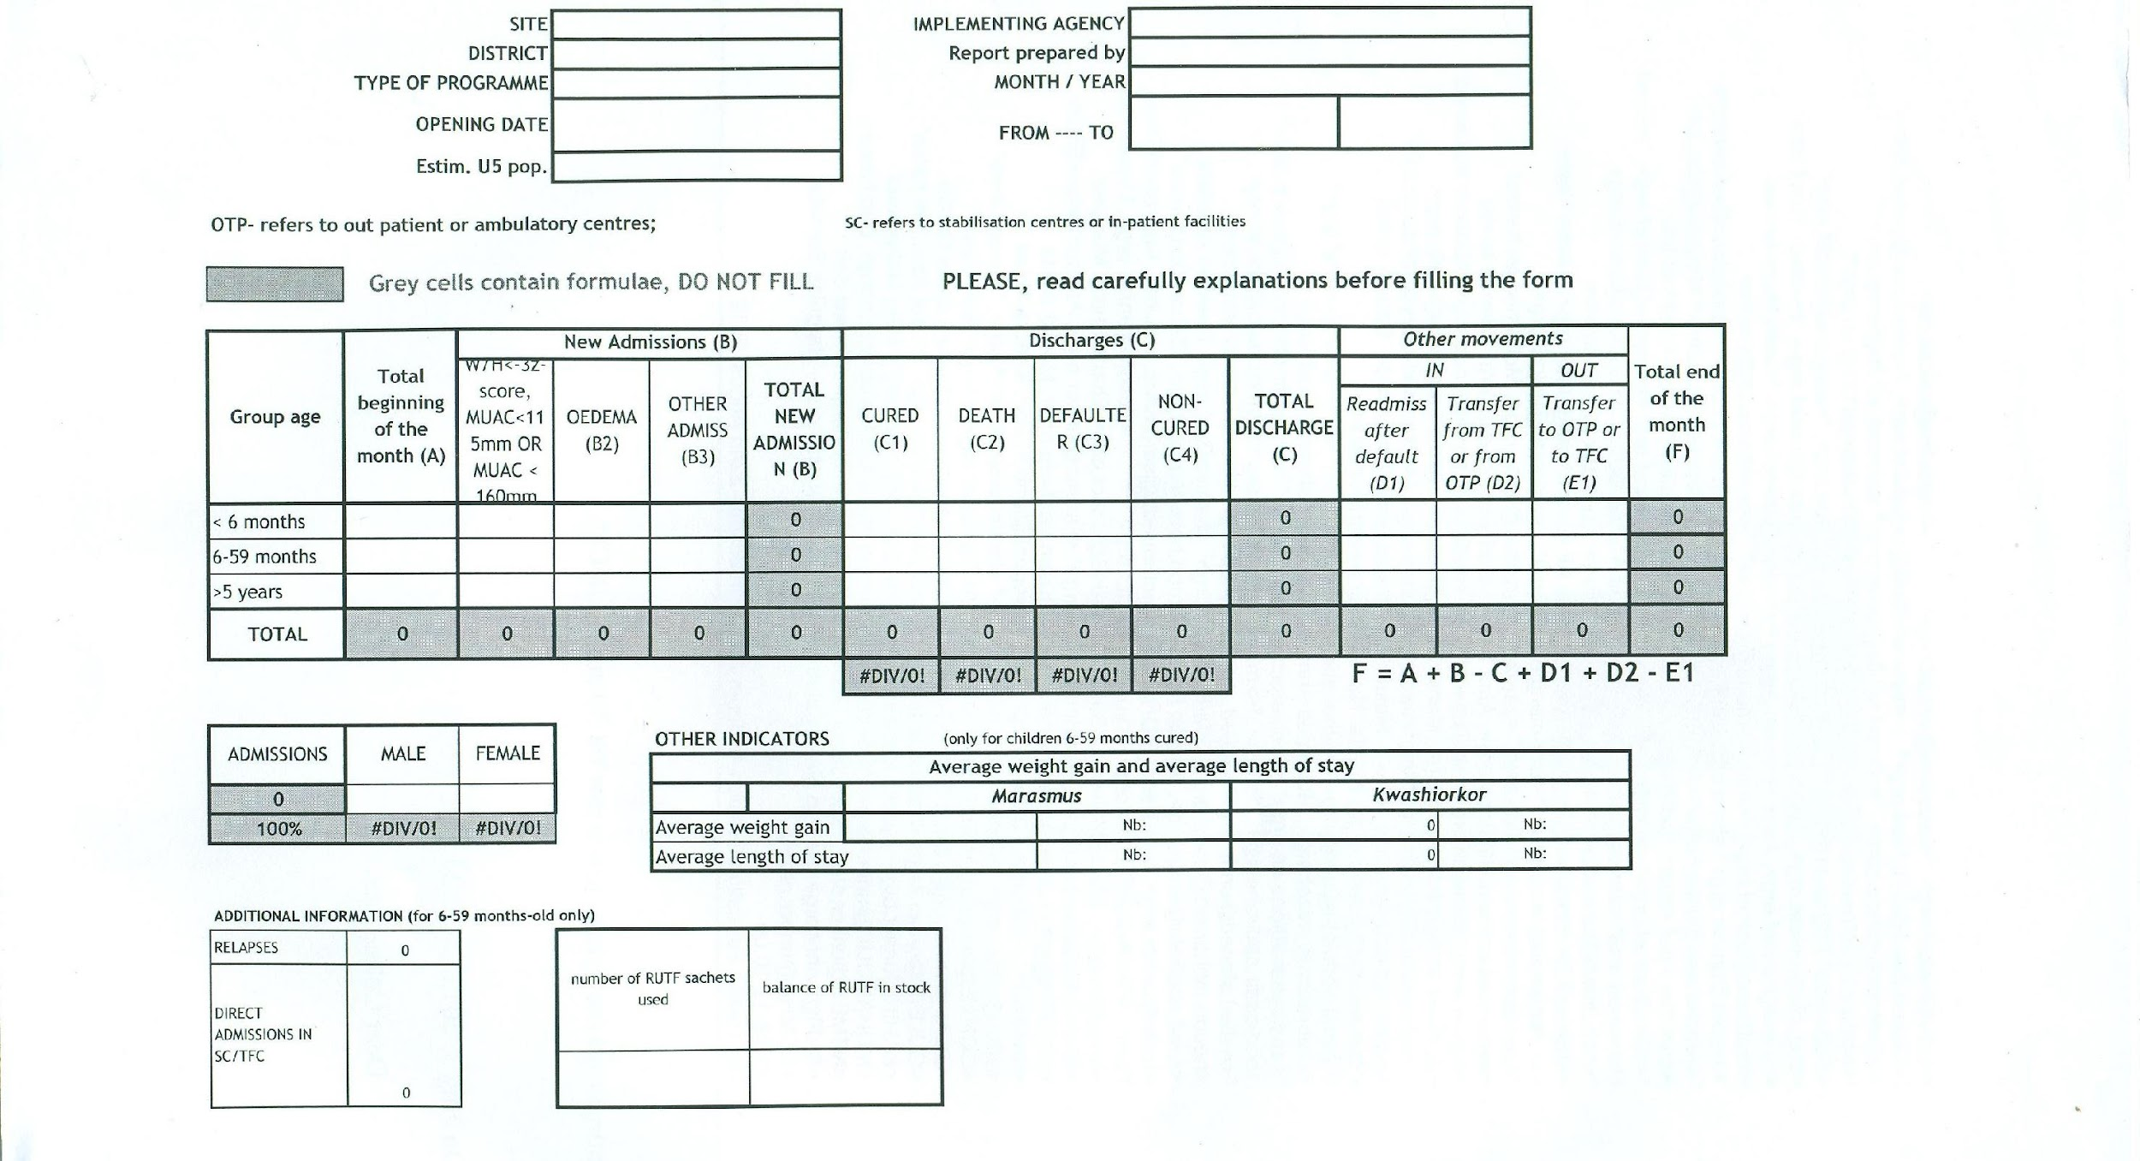

**Figure 5: Figure 4: UNICEF monthly report from implementers to UNICEF headquarter in Haregeisa. This report summarizes diagnosis into Outpatient Therapeutic Program (outpatient Care).**

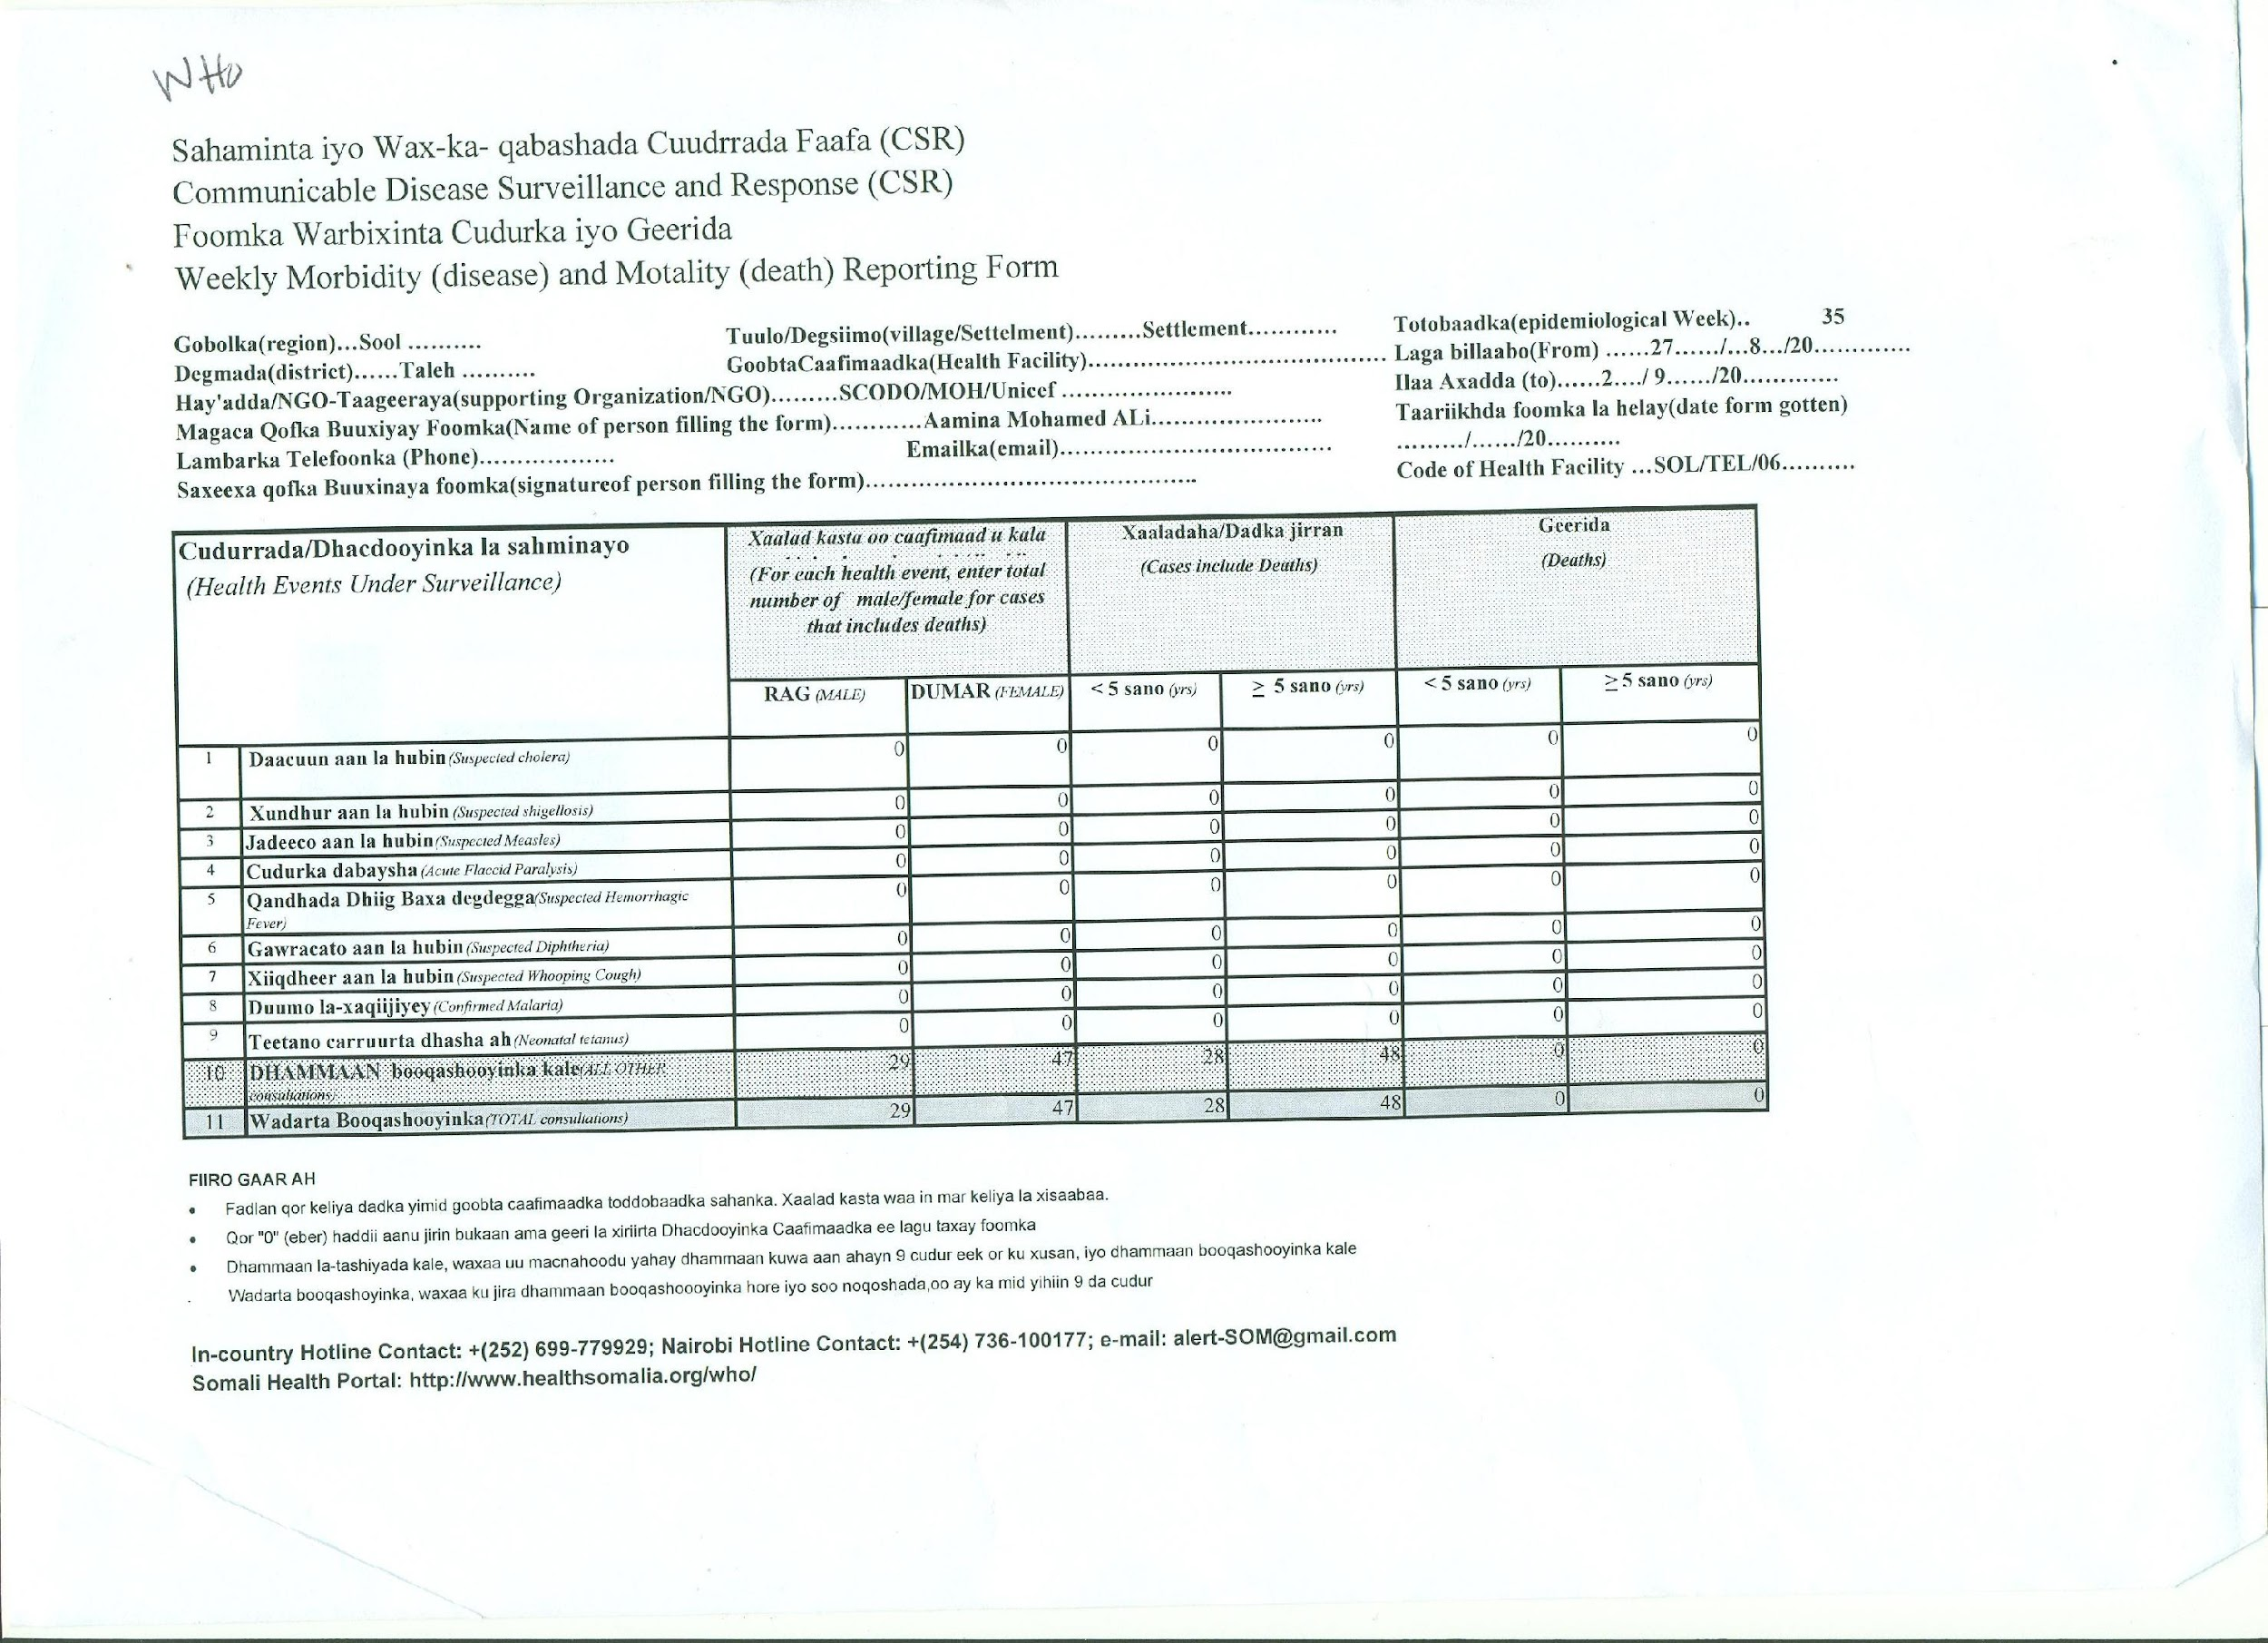

**Figure 6: WHO weekly report from WHO health monitors units across somalia. This report summerizes Communicable Disease Surveillance and Response (CSR)**

**5.1. References**

Ahmed, Ali J (1995) (ed.), The Invention of Somalia, Lawrenceville: Red Sea Press. Bradbury, M (1994), 'The Somali Conflict: Prospects for peace',

Somaliland in Figures, Somaliland Ministry of National Planning 2003, <http://siteresources.worldbank.org/SOMALIAEXTN/Resources/Somaliland_in_Figures.pdf> Somaliland National Development Plan 2012, Ministry of Planning.

Somaliland National Budget 2012, Ministry of Finance.

World Food Program, <http://www.wfp.org/countries/somalia/operations> Somalia Health Cluster, <http://healthsomalia.org/>

Jeff Howe (2006). "The Rise of Crowdsourcing", Wired Magazine. [http://crowdfundamerica.org/crowdfund-­‐](http://crowdfundamerica.org/crowdfund-)international/africa/

MIT’s EPROM center, 2009, <http://media.mit.edu/ventures/EPROM/whyafrica.html> <http://www.voxeo.com/library/ivr.jsp>

Food and Agriculture Organization, <http://www.faosomalia.org/>

Food Security and Nutrition Analysis Unit (FSNAU), 2012 progress Report, [http://fsnau.org](http://fsnau.org/) Somaliland in Figures, Somaliland Ministry of National Planning 2012,

Somalia Health Cluster

Google Open Data [Kit, http://opendatakit.org/](http://opendatakit.org/)